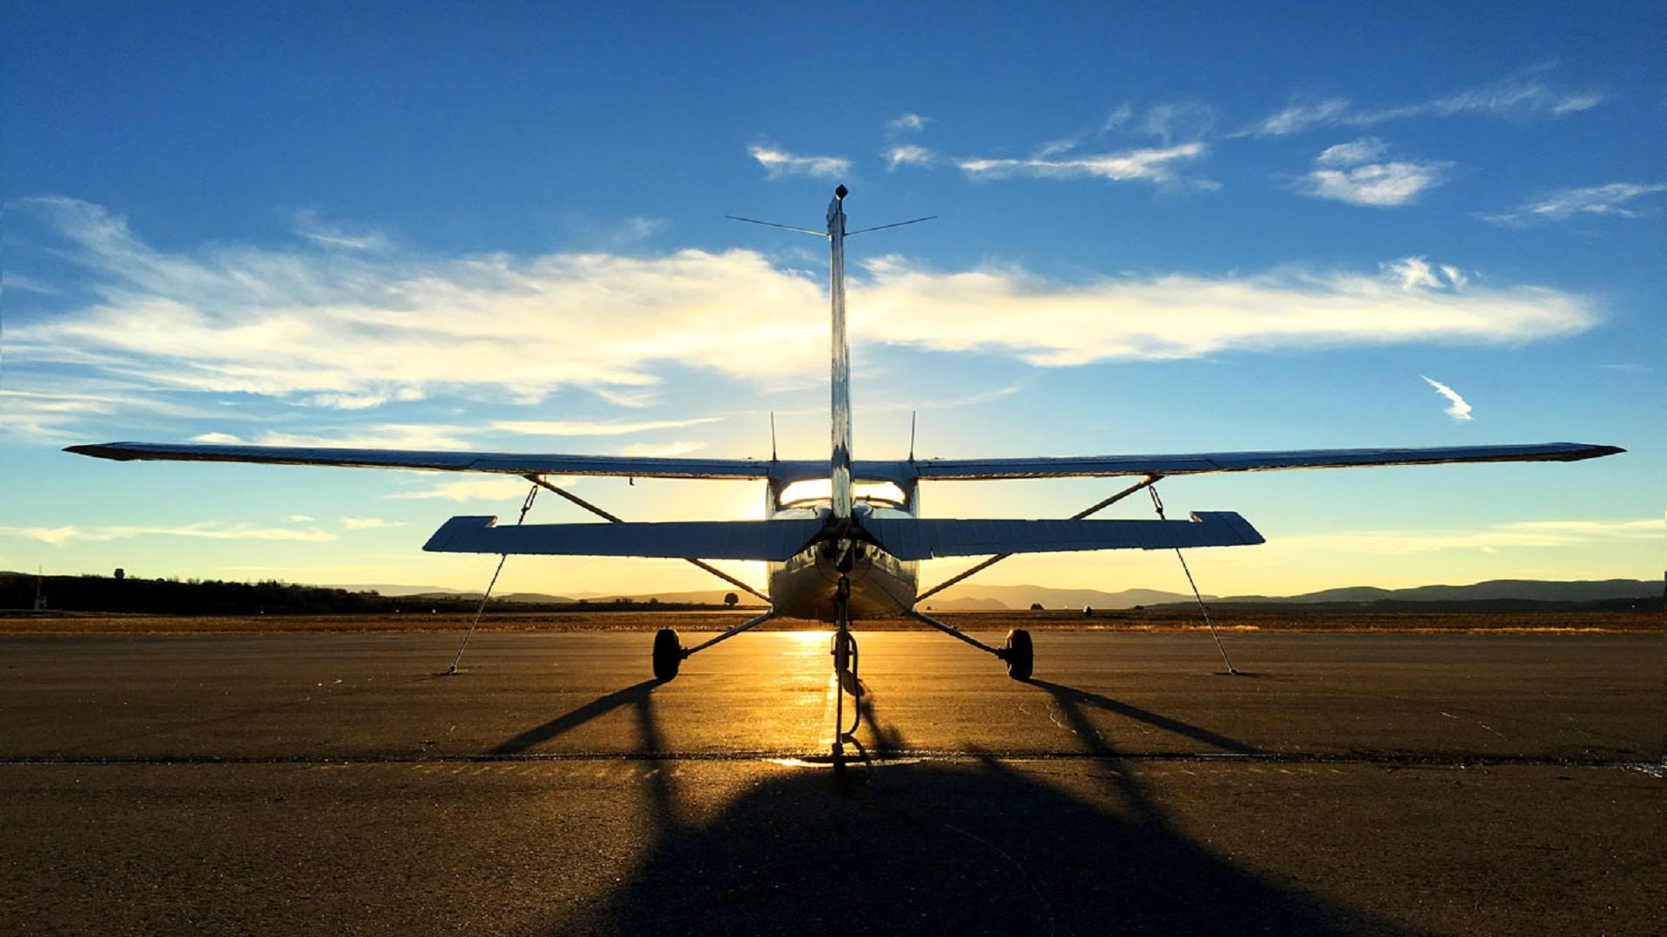
Sample Curriculum
Young Aviator Academy
Avia Flight Academy

Lesson 1: Introduction to aviation
- History of flight
- What is aviation anyway?
- Major parts of an airplane
- Activity: Identify plane parts on a real plane - tour of the airplane
- Game time – let’s see what we learned

Lesson 2: Principles of flight
- How airplanes move
- Forces of flight
- Theories of production of lift: Newton and Bernoulli
- Scenario play: Theories of production of lift
- Activity: Produce own lift device
- Game time – let’s see what we learned

Lesson 3: Airplane controls and instruments
- Flight controls - primary and secondary
- Flight instruments
- Simulator: Let’s put it into practice

Lesson 4: Airport operations and safety
- Airport operations
- FAA role
- Safety procedures
- Pilot codes with activity
- Game time – let’s see what we learned

Lesson 5: Pre-flight planning and beyond
- What to expect during your first flight with an instructor?
- What is pre- flight planning?
- How to taxi, takeoff, climb, descend and landing
- Scenario play: Prep for your flight

Lesson 6: First flight with your instructor
- Everything we have learned so far comes together in a flight lesson
- You will learn how taxi a plane, take off, climb, descend and land
- If you feel comfortable, you can take the controls of the plane, don’t worry, your instructor is next to you ready to take it back

Lesson 7: Communications and weather
- Traffic control tower – tour
- Weather reports and how to read them
- Structure of the atmosphere (atmospheric pressure, pressure altitude, density)
- Activity and game - let’s see what we learned

You made it. You have some serious flight training under your belt. Congratulations!
GRADUATION!

