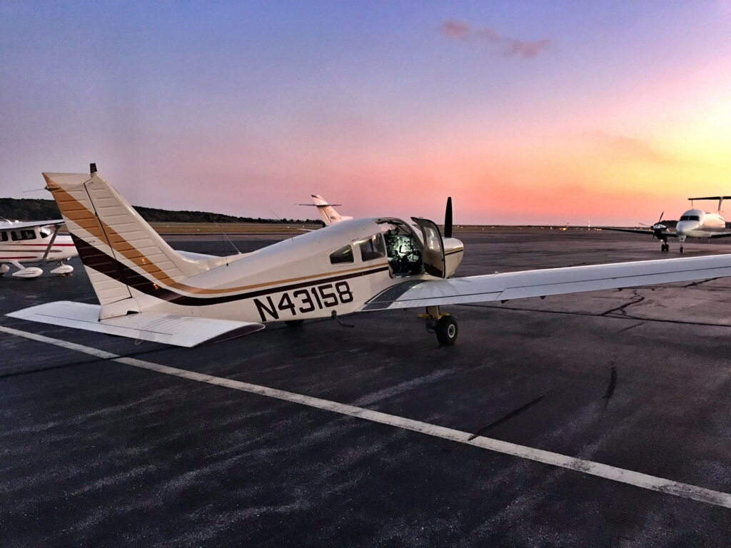
Sample Curriculum
Young Aviator Academy
Avia Flight Academy

Lesson 1: Introduction to aviation
- History of flight
- What is aviation anyway?
- Careers in aviation
- Major parts of an airplane
- Activity: Identify plane parts on a real plane - tour of the airplane
- Game time – let’s see what we learned

Lesson 2: Principles of flight
- How airplanes move
- Forces of flight
- Theories of production of lift: Newton and Bernoulli
- Scenario play: Theories of production of lift
- Activity: Produce own lift device
- Game time – let’s see what we learned

Lesson 3: Airplane controls and instruments
- Flight controls - primary and secondary
- Flight instruments
- Simulator: Let’s put it into practice

Lesson 4: Airport operations, safety and communications
- Airport operations
- FAA role
- Safety procedures
- Pilot codes with activity
- Radio communications
- Traffics pattern basics
- Tour: Traffic control tower
- Game time – let’s see what we learned

Lesson 5: Pre-flight planning and beyond
- Pre- flight planning
- How to taxi, takeoff, climb, descend and landing
- Weight and balance
- Basic weather reports
- What to expect during your first flight with an instructor?
- Scenario play: Prep for your flight and conduct pre-flight safety briefing with your instructor just like a real pilot does (Combo of classroom and plane tour activity. Pre-flight briefings are conducted on the airplane).

Lesson 6: First flight with your instructor
- Everything we have learned so far comes together in a flight lesson
- You will learn how taxi a plane, take off, climb, descend and land
- If you feel comfortable, you can take the controls of the plane, don’t worry, your instructor is next to you ready to take it back

You made it. You have some serious flight training under your belt. Congratulations!
GRADUATION!

